Seesaw Instructions
You may find it easier to use the program on a tablet rather than a laptop or computer as there is camera function already built into the device. You can either access it using the website https://app.seesaw.me/ or download the free app ‘Seesaw Class’.
When the children log on they will see a range of tasks in their inbox, there will probably be lots on a Monday as the whole week’s work has been set in one go. Find the correct task for today’s date.

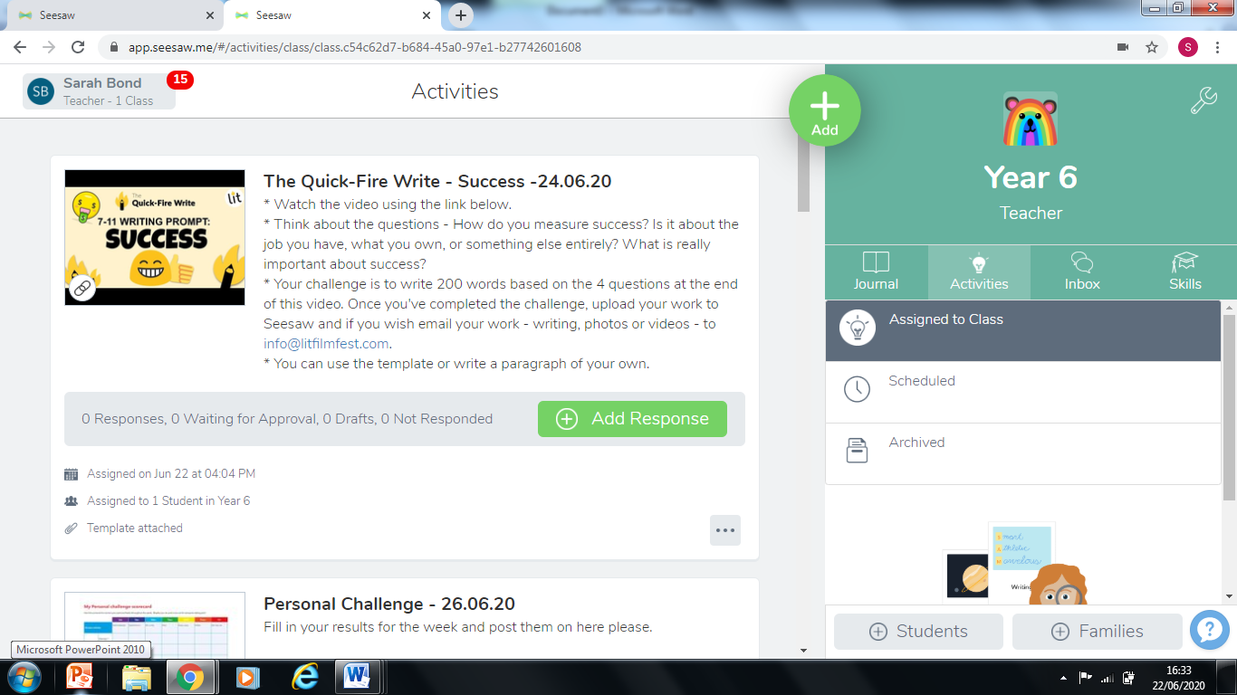
When you click ‘add response’ in green, you will be taken onto the worksheet (if one has been uploaded). Then you can see the worksheet plus a range of tools.
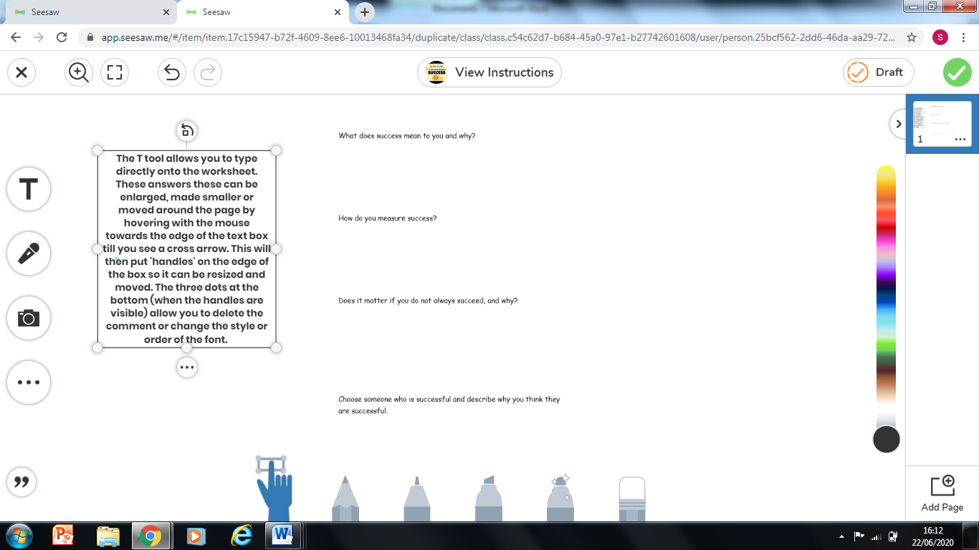
The T tool
The T tool allows you to type directly onto (or around the outside of the document (teachers can see whatever is typed when you submit the document so don’t worry too much about putting it in the correct place.) When you begin typing the text is quite large so you will probably want to resize it. You do this by hovering the mouse around the outside of the text box until you see a cross arrow. When you see this arrow, click. This will then put handles onto the edge of the box. This means it can be resized and moved. If you click on the three dots below the box (when the handles are visible) you will have the options to change the font, alignment of the text or delete it.
The Camera Tool
There is also the option to upload or take a photograph if the child has done the work in a book or on paper. The teacher will be able to see this photo when you submit the work. You can either click the first option ‘photo’ which will access your camera (this will work best if logged in on a tablet or phone) or ‘upload’ if you have the photo already saved.
The Pen Tools
At the bottom of the screen are a range of pen tools, these can be manipulated using a mouse if on a computer/laptop or by the touchscreen if using a phone or tablet. These tend to only be used for short answers (eg numbers in Maths) as they can be quite difficult to control.
Undo/Redo arrows
These are located at the top of the workspace and can be used if something is deleted in error etc.
View Instructions
Shows you the instructions for the task without taking you out of the task.
Green Submit Tick
When you are happy with the response you click on the green tick which submits the work to the teacher. It will then disappear out of the child’s ‘in tray.’
Other ways of submitting work.
If there is no worksheet attached for the task you will have a range of options for submitting your work.
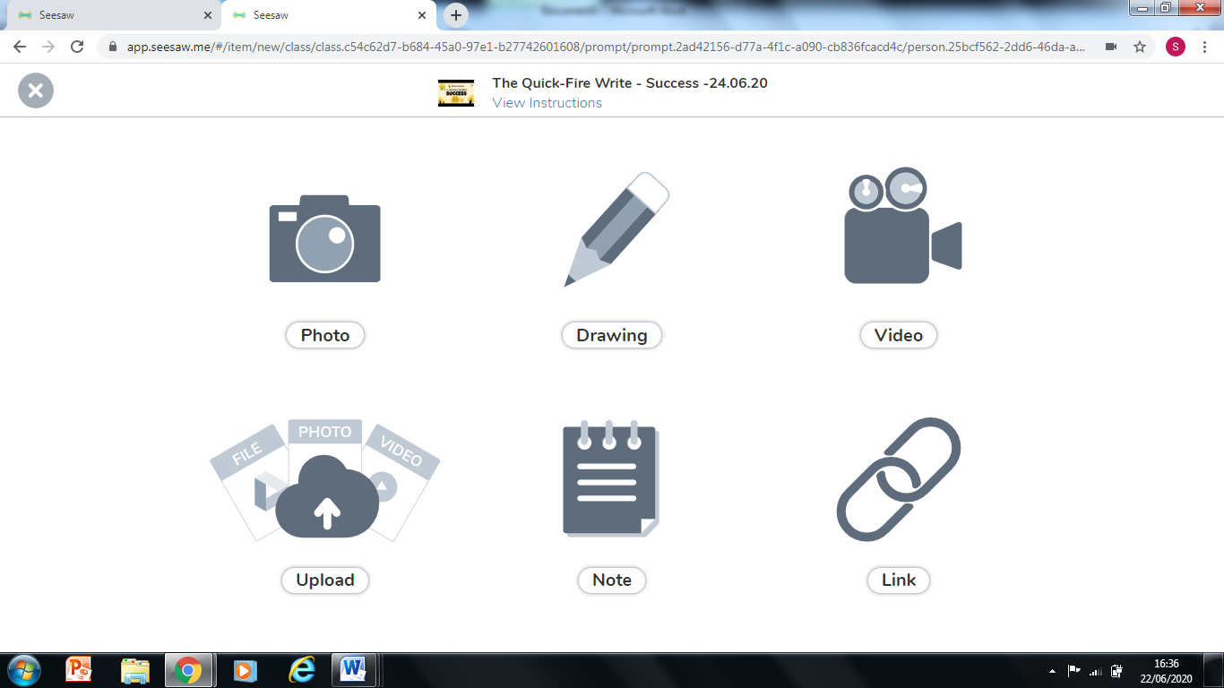
Photo
You can use the photo option to take a photograph of the work and submit it.
Video
Take a video of the work.
Note
This option allows you to type longer messages/paragraphs for writing etc.
Printing Work
If you are wanting to print work out for example for a child to complete a handwritten copy of a worksheet rather than on screen. You need to click on the picture of the worksheet when it is in the ‘in tray’ (next to the instructions) and you will have the option to view the original. Click this and it will give you a PDF of the document which you can then print out in the traditional way.
https://www.youtube.com/watch?v=6cLZma-VzhM I found this video which probably explains it better than me!

There are also some other help videos, that may be useful on a range of topics here.
https://web.seesaw.me/get-students-started
Hope this helps, please let me know if there is anything else I can do to help.
Miss Bond

