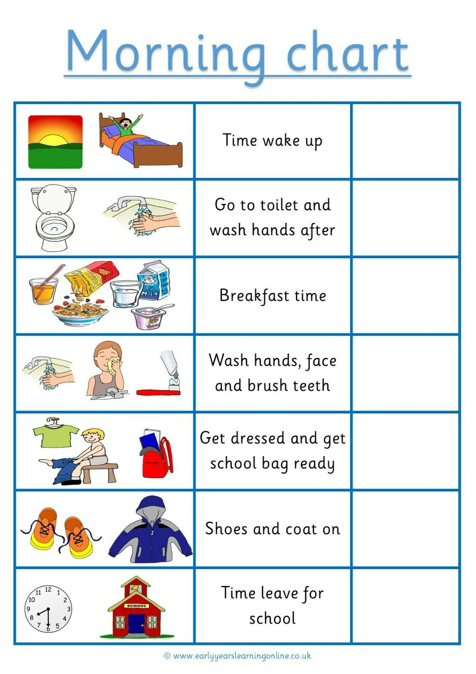

**Go to the toilet and wash your hands**

**Wake up**