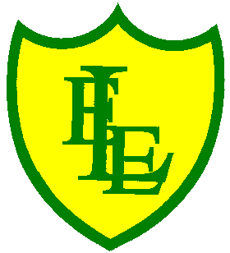
ECCLESTON LANE ENDS
SCHOOL CLOSURE WORK

YEAR: 2
DATE: Wednesday 24th June 2020

PE: 9-9.30am
Log in to YouTube at 9am to access a 30-minute PE lesson with Joe Wicks, the body coach. https://www.youtube.com/user/thebodycoach1 Also, take a look at the keeping active and mindful website Fitter Future, for some different activities to stay active during this time.

Reading
Carry on reading Poppa Joe’s Red Racer. In chapter three, Poppa Joe has arrived! Mia’s dad shows Mia Poppa Joe’s rusty old pedal car. He thinks it will help her with her school project.
Please complete the activities once you’ve this chapter.

Spellings
This week’s spellings are:

Handwriting practise sheets for this week’s spellings are available to download on spelling section at the top of our class page.

English
Continuing with the fable story ‘The Bridge’ play the clip from the beginning, pausing at 0:21, imagine if animals could speak in real life. Do the animals in the clip behave/ move as though real animals would? What the animals might say to one another at this point. How are they both feeling? What is the bear’s reaction to the elk bumping into him? What do they think would be a better reaction? Continue to play the clip, pausing again at 0:40, then repeating the question “What could the animals have been saying?” Write your reactions and sentences in your home learning journal using inverted commas (speech marks remember our rule 66 when someone starts to speak and 99 when they finish speaking. They float above your words). Remember to use high quality vocabulary in your writing and your imagination, try to use ‘and’ or other conjunctions to extend your sentences.
https://www.youtube.com/watch?v=_X_AfRk9F9w
Maths
Today’s maths objective is to be able to group 3-D shapes by similar properties.
Can you sort these shapes into groups? What will you call the different groups?
For today’s maths activity the children are to identify how the 3D shapes have been grouped. Encourage them to think of more than one criterion for sorting, focusing on the properties of the 3-D shapes. For example some shapes might be sorted by type, size, number of sides or curved faces.

Activity - There are three different levels starting at level 1 on page 1.
Page 1 includes questions to support sorting 3D shapes, with all shapes presented in the same orientation and size.
Page 2 includes questions to support sorting 3D shapes, with reference to the number of faces, edges and vertices.
Page 3 includes questions to support sorting 3D shapes, with reference to the number of faces, edges and vertices and shapes presented in different orientations and sizes

Geography
Thinking about our previous work on St.Ives. Can you think about and answer the following questions.
What did you find out about St. Ives?
What attractions are there?
What do you think the weather is like?
Why do you think tourists visit St Ives?

Today you are going to imagine you are a tour guide in St. Ives.
You are going to plan a guided tour around St. Ives using a map. You must visit at least 5 locations, use compass directions and position key words (near, far, left, right) to describe the route (see attached worksheet).
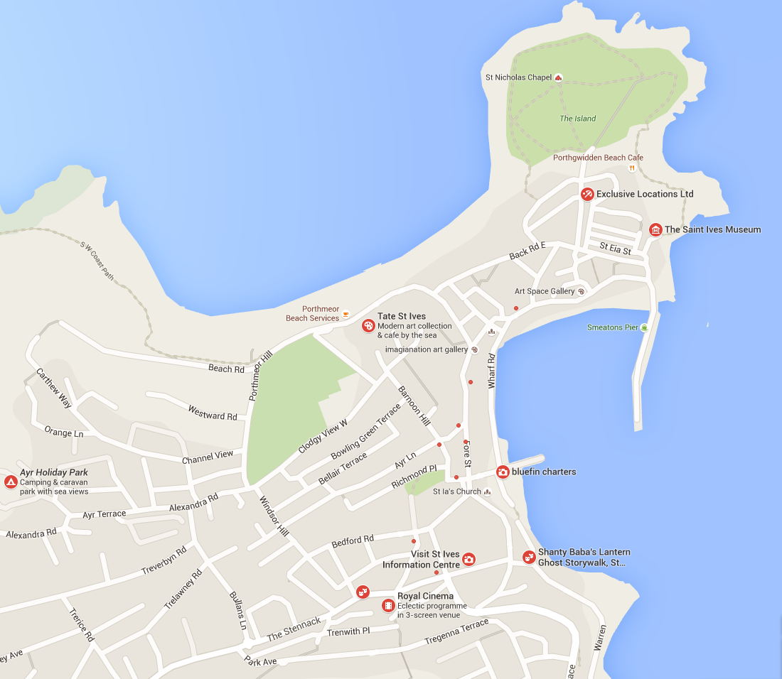

Challenge- Can you compare where you live to St.Ives?

Maybe creating thinking points such as; attractions nearby, places to eat, places to go, things to do etc.

