Design a lighthouse.

A lighthouse is a tall building that has a light near the top. Lighthouses are built on the coast of an ocean or lake. The lighthouse protects ships from crashing into shore by sending the light out towards the sea. The light usually turns in a circle so that ships see a flashing light. The light is usually covered by a Fresnel lens. This lens enables the light to travel a far distance.
Your task today is to research how to make a simple lighthouse.
You will need to list your equipment that you are using, draw and label your lighthouse. (You should of been gathering the equipment over the last week as per the home learning sheets)
- List your equipment you will be using.
- Write the steps in order of what you need to do, this is important so when you do construct your lighthouse, you can see the correct order to do things and what equipment to use. (use commas in a list, time openers: First, Next, After)
- Think about the size of your lighthouse. You can only build it as tall as the equipment you have.
- Draw your finished design and label the lighthouse with the equipment and colours you will be using.
- Do this in your home learning book, so when we do collect your home schooling working evidence we can see your design.

Parents- Questions you could ask your child
What is a lighthouse? What does it do?
What does the lighthouse in the story do?
Why are lighthouses important?
How can you decorate your lighthouse?
What colours are you going to use? Why?
What could you use there?

Examples of lighthouses (Mrs Clarke use to have a house that faced the lighthouse in Jersey, it was fabulous to look out each day and see, every day the waves would crash onto the rocks underneath it.)
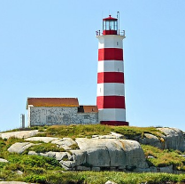
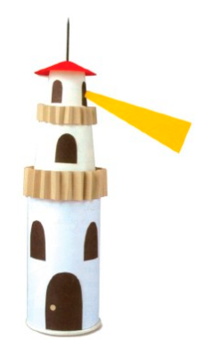
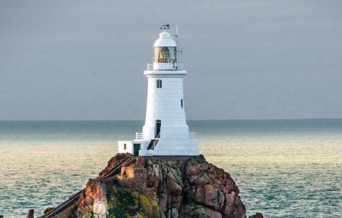
Sambro Island lighthouse, Canada
La Corbiere lighthouse, Jersey
Paper lighthouse

