My Bunting Design

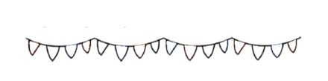

I will need ____________, ______________, ____________

_______________, _______________ and ______________

Here is my design

My Bunting Design

