







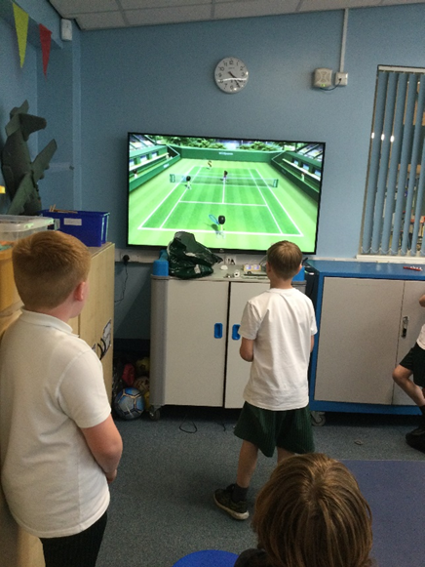

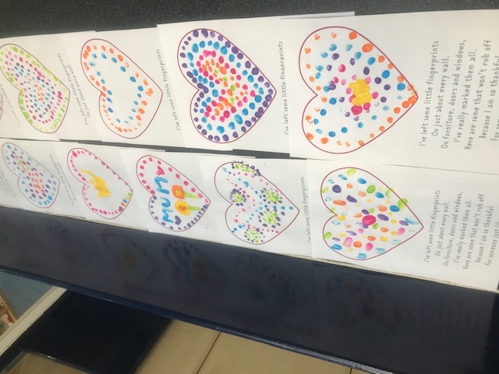

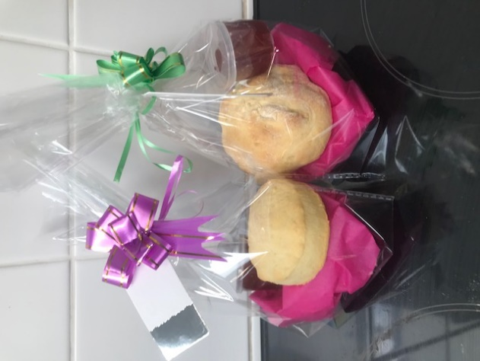

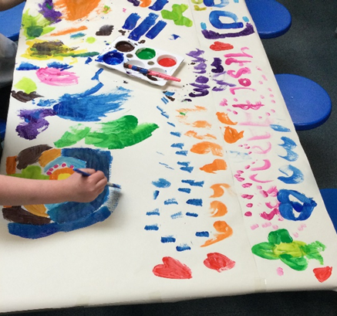

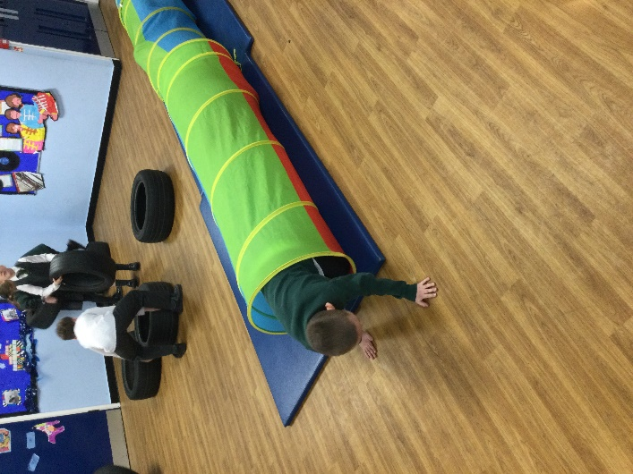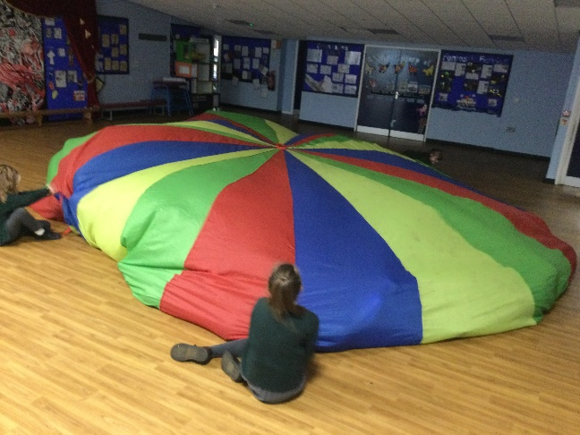



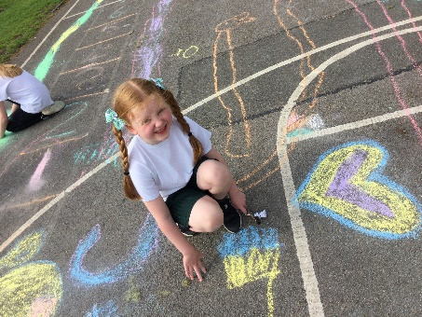Here at FACES we offer a range of fun and exciting activities to do, these include:

* Arts and crafts
* Themed night such as Chinese New Year and International week
* 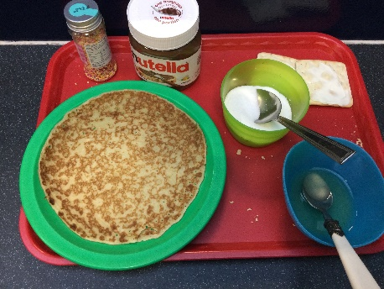Sports and outdoor games
* Games night
* Reading
* Homework club on Mondays for KS2
* Baking
* Dancing
* Yoga
* Movie night and much more.

We also provide a healthy, balanced breakfast/afterschool snack. For breakfast, children can choose from a variety of cereals, toast and scotch pancakes with milk, water or juice.

During afterschool club, we provide a healthy snack. This can include sandwiches, crackers and houmous with salad/fruit. The menu is changed regularly to encourage the children to try new things. When we have themed nights, the children have the opportunity to try foods from all over the world. During International Week, the children tried foods from Spain, Mexico, France and Germany. We have received rave reviews and the children enjoy giving us their ideas of things they would like to try!

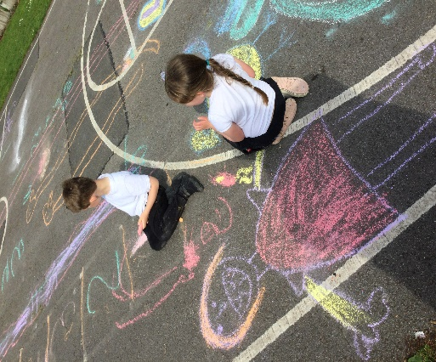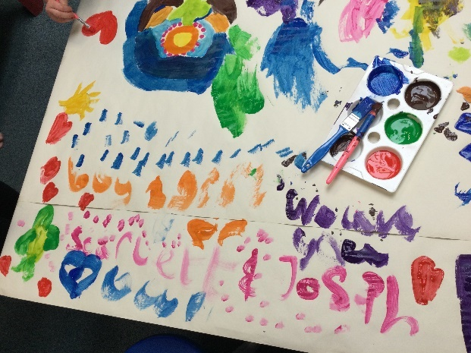

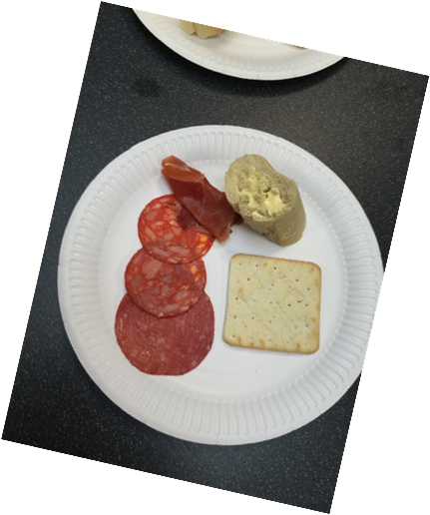

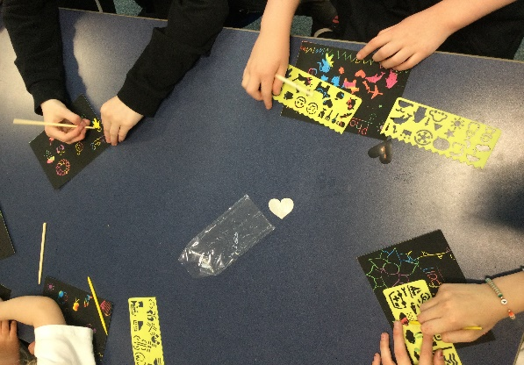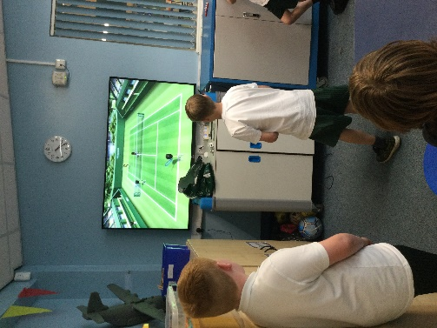

Dear Parent/Carer

If you would like to register your child for a place at Eccleston Lane Ends breakfast/after school club please read and complete the enclosed forms.

The forms are a requirement as part of the schools safeguarding policy to ensure the wellbeing of your child.

Thank you for your interest and co-operation.

Miss Luter (FACES Manager) and ELE

Finance and Pricing

The following fees are to cover staffing, food, drink and any resources needed to run FACES to ensure the best experience for your child.

The fees are £4 per child for Breakfast Club and £7 for After School Club. We require booking and payments in advance unless the provision is required in an emergency. Payments are made online and childcare vouchers are also accepted.

We understand that circumstances can change but where possible we would require cancellations to be made more than 24 hours before the booking.

If you wish to contact us regarding any information in this booklet or any other matter regarding FACES please contact us on 07742521861 or email laneends@sthelens.org.uk.

**Terms and Conditions**

The after school club aims to provide

* A caring and stimulating environment for all children who use the facility.
* A safe and fun place to be, a place children want to go to.
* A high quality and value for money provision that fulfills the needs of our parents
* The club will have the same high expectations and standards as the school. All staff, parents and children will be made aware of this.

1. Breakfast club is available from 7.30-8.45. After School club is provided from the end of the school day to 6:00pm.
2. Parents/Carers agree to collect their child by 6.00pm. Staff are not employed to care for children after this time. It is the parent’s responsibility to arrange for another person to collect their child if they are unable to collect them. We ask that parents inform staff in advance of any changes to normal arrangements.
3. Parents are asked to book places on Friday, prior to each week and on the School Money App. Places will be allocated on a first come first served basis. Places cannot be guaranteed because of the strict adult/child ratio in compliance with OFSTED regulations. The manager will contact you in the event of a place not being available. Fees will only be refunded if a place is cancelled with a minimum of 24 hours notice (except where a child is absent from school through illness).
4. Children are expected to display the same high standards they demonstrate throughout the school day. Staff will inform parents when the behaviour of a child becomes a concern. The staff reserve the right to withdraw the service as a result of repeated poor behaviour.
5. Any complaints/concerns should be directed to the school. In the event of the matter not being resolved please contact Miss Bond or the After School Club Committee of the Governing Body.

**I have read and accept the terms and conditions of E.L.E. F.A.C.E.S. Club**

**Signed__________________________________________________________**

**Name (please print)______________________________________________**







